

AN AI-BASED SMART CAR ACCIDENT DETECTION, SEVERITY CLASSIFICATION, AND EMERGENCY ALERT SYSTEM USING MULTI-SENSOR DATA AND CLOUD COMMUNICATION

By
Francoise MUKESHIMANA

May 2026

DECLARATION
We do hereby declare that this Project submitted in partial fulfilment of the requirement for the
Advanced Diploma in Electronics and Telecommunication Technology, at RP-Kigali College,
is our original work and has not previously been submitted elsewhere. Also, we do declare that
a complete list of references is provided indicating all the sources of information quoted or
cited.
Names signature

APPROVAL PAGE
I confirm that the work reported in this research project was carried out by the candidates under
my supervision and it has been submitted with my approval as the RP-Kigali College
supervisor.

Project Supervisor’s Name: ____________________________________
Sign:_________________________________________
Date:_________________________________________

Head of Department’s Name:__________________________________
Sign:________________________________________
Date:________________________________________

ABSTRACT
Road traffic accidents remain one of the leading causes of injury and death in Rwanda and worldwide, often worsened by delayed emergency response. This project presents an AI-Based Smart Car Accident Detection System designed to improve the speed and accuracy of accident identification and response. The system integrates sensors, microcontrollers, GPS modules, and artificial intelligence algorithms to detect collision events in real time. When an accident occurs, the system automatically analyzes sudden changes in motion, impact force, and vehicle orientation to confirm the incident. Once verified, it immediately sends alerts containing the vehicle’s location and accident details to emergency services and predefined contacts through cloud connectivity. The proposed solution enhances traditional safety systems by reducing human dependency and minimizing response time after accidents. Machine learning techniques are applied to improve detection accuracy and reduce false alarms caused by harsh braking or road conditions. The system is designed to be cost-effective, scalable, and suitable for integration into modern vehicles. By combining IoT communication and AI-based decision-making, this project aims to contribute to smarter transportation systems and improved road safety. Ultimately, the system helps save lives by ensuring faster emergency intervention and providing reliable real-time accident monitoring in connected vehicles.

Keywords: Artificial Intelligence, Accident Detection, Internet of Things (IoT), Smart Vehicle, Emergency Response

Table of Contents
DECLARATION 1
APPROVAL PAGE 2
ABSTRACT 3
CHAPTER ONE: GENERAL INTRODUCTION 5
1.1 Introduction 5
1.2 Background of the Study 5
1.3 Statement of the Problem 6
1.4 Purpose of the Study 6
1.5 Research Objectives 7
1.5.1 Main Objective 7
1.5.2 Specific Objectives 7
1.6 Scope of the Study 7
1.7 Significance of the Study 7
CHAPTER TWO: LITERATURE REVIEW 9
2.1 Introduction 9
2.2 Relevant Theories and Concepts 9
2.3 Related Works 10
2.4 Identified Gaps 12
2.5 Theoretical Framework 12
2.6 Summary 13
CHAPTER THREE: METHODOLOGY 14
3.1 Introduction 14
3.2 Research Design 14
3.3 Participants/Subjects 14
3.4 Data Collection Methods 15
3.5 Instrumentation 15
3.6 Data Analysis Techniques 16
REFERENCES 17

CHAPTER ONE: GENERAL INTRODUCTION

Introduction
The transportation sector faces serious safety challenges, with road traffic accidents being one of the leading causes of death and injury worldwide, especially in developing countries like Rwanda. These accidents are commonly caused by factors such as overspeeding, reckless driving, poor road conditions, and lack of timely emergency response. In many situations, the major problem is not only the occurrence of the accident but also the delay in detecting it and providing immediate assistance to the victims. Most accident reporting still depends on eyewitnesses or the victims themselves, which becomes a serious issue when victims are unconscious or unable to call for help. As a result, emergency services such as ambulances and police often arrive late, increasing the risk of death or severe injury. With the advancement of technologies such as Artificial Intelligence (AI), Internet of Things (IoT), and cloud communication, it is now possible to design intelligent systems that can automatically detect accidents and respond quickly. This research introduces an AI-based smart car accident detection, severity classification, and emergency alert system that uses multi-sensor data and cloud communication to improve road safety by enabling real-time detection, intelligent analysis, and automatic emergency response.

Background of the Study
The transportation industry is one of the most important sectors supporting economic growth and daily life activities in Rwanda and across the world, but it is also associated with major challenges related to road safety. Road accidents have become a serious issue due to their impact on human lives, property, and the economy. According to data published by the World Health Organization (WHO, 2020), road traffic accidents in Rwanda accounted for approximately 3,718 deaths, representing about 6.41% of total deaths, which highlights the severity of the problem. The government of Rwanda has implemented various safety measures such as speed limit signs, traffic laws, speed cameras, and vehicle inspections to reduce accidents, but these measures still rely heavily on human behavior and compliance. In many cases, drivers ignore traffic rules, and accidents still occur due to human error. Additionally, when accidents happen, there is often a delay in reporting them, especially in remote areas or during night hours, which increases the chances of fatalities. With the development of modern technologies such as Artificial Intelligence, cloud computing, and IoT, there is an opportunity to improve accident detection and response systems. The proposed system combines sensors, camera, GPS, and cloud-based AI to automatically detect accidents, analyze their severity, and send alerts, providing a more reliable and efficient solution to improving road safety in Rwanda.

Statement of the Problem
Road safety remains a critical concern globally and in Rwanda, where road accidents continue to cause deaths, injuries, and destruction of property. One of the major challenges in accident management is the delay in detecting accidents and notifying emergency services. In many cases, victims are unable to report accidents due to injuries or unconsciousness, which leads to delayed medical assistance and increases the risk of death. Existing systems mostly depend on human reporting or basic sensor detection without intelligent decision-making, making them unreliable in critical situations.
Furthermore, current solutions do not effectively analyze the severity of accidents, which is important for determining the level of response required. Some systems may send alerts even for minor incidents, while serious accidents may not receive immediate attention due to lack of proper analysis. This creates a significant risk, especially on highways and in rural areas where monitoring systems are limited. Therefore, there is a need for an intelligent system that can automatically detect accidents, analyze their severity using artificial intelligence, and send accurate and timely alerts to emergency responders. The proposed system aims to address these challenges by integrating multi-sensor detection, AI-based analysis, and cloud communication to improve response time and enhance road safety.

1.4 Purpose of the Study
The purpose of this study is to design and implement an AI-based smart system capable of automatically detecting car accidents, classifying their severity using artificial intelligence, and sending emergency alerts through cloud communication. The system aims to reduce delays in accident detection and response, improve the accuracy of information provided to emergency services, and ultimately save lives by ensuring that victims receive timely assistance. In addition, the system supports the development of smart transportation solutions that enhance road safety and reduce the impact of accidents in Rwanda.

1.5 Research Objectives

1.5.1 Main Objective
To design and implement an AI-based smart car accident detection, severity classification, and emergency alert system using multi-sensor data and cloud communication.

1.5.2 Specific Objectives
- To develop a sensor-based accident reporting system that detects collisions and collects real-time data.
- To design and train a machine learning model using a web-based interface for analyzing accident data and classifying severity.
- To implement a cloud-based system for accident severity visualization and classification to support decision-making and emergency response.

1.6 Scope of the Study
This study focuses on the development of an AI-based smart car accident detection and emergency alert system using embedded systems and cloud technology. The system will use sensors to detect impact and abnormal movement, a camera to capture images of the accident scene, and a GPS module to determine the exact location. The collected data will be transmitted to a cloud platform where artificial intelligence will be used to analyze the severity of the accident and make decisions. The project will be implemented as a prototype under controlled conditions to simulate real-world scenarios, and it will demonstrate how such a system can be applied in improving road safety in Rwanda.

1.7 Significance of the Study
The development of an AI-based smart accident detection and emergency alert system is highly significant in improving road safety in Rwanda by reducing the time taken to detect accidents and respond to emergencies. By automatically identifying accidents and sending alerts with accurate location and severity information, the system helps emergency services respond faster, which can save lives and reduce the severity of injuries. The use of artificial intelligence improves decision-making by ensuring that only serious cases trigger immediate alerts, thereby reducing false alarms and improving efficiency. In addition, the system contributes to reducing economic losses caused by accidents, such as medical expenses and vehicle damage, while also supporting government efforts to modernize transportation systems and enhance road safety management. This project provides an innovative and practical solution that integrates modern technologies such as AI, IoT, and cloud computing to address real-world challenges in Rwanda’s transportation sector.

CHAPTER TWO: LITERATURE REVIEW

2.1 Introduction
This chapter presents a review of related studies and technologies used in intelligent transportation systems, especially in the areas of accident detection, machine learning, and cloud-based emergency communication systems. The review focuses on different approaches used by researchers to improve road safety through the use of sensors, artificial intelligence, GPS tracking, and internet communication technologies. It also explains how modern technologies are being used to detect accidents automatically and send emergency alerts in real time. In addition, this chapter discusses the limitations of existing systems such as inaccurate accident detection, false alerts, lack of severity classification, and dependence on traditional communication methods like GSM and SMS. The purpose of this review is to understand the current state of research, identify existing gaps, and provide a strong foundation for the proposed AI-based smart car accident detection, severity classification, and emergency alert system using multi-sensor data and cloud communication in Rwanda.

2.2 Relevant Theories and Concepts

Artificial Intelligence (AI)
Artificial Intelligence refers to the ability of computer systems to perform tasks that normally require human intelligence such as decision-making, pattern recognition, and problem solving. In this project, AI is used to analyze sensor data and classify accident severity levels automatically. AI helps improve the accuracy and reliability of accident detection systems compared to traditional manual methods.
Machine Learning
Machine learning is a branch of artificial intelligence that allows computer systems to learn from data and improve performance without being directly programmed for every situation. Machine learning algorithms are trained using collected sensor data to identify accident conditions and classify accident severity into different categories such as low, medium, and high severity.
Internet of Things (IoT)
The Internet of Things refers to the connection of physical devices through the internet to collect and exchange data. In this project, IoT technology allows sensors, ESP32 microcontroller, and the web server to communicate in real time. This enables automatic transmission of accident information and emergency alerts through cloud communication.
Cloud Communication
Cloud communication is the use of internet-based platforms to store, process, and exchange information remotely. In the proposed system, cloud communication is used to send accident data from the vehicle to the web server where information can be monitored and analyzed through a web dashboard. Cloud communication also allows emergency alerts to be sent instantly through WhatsApp messaging.
Multi-Sensor Accident Detection
Multi-sensor accident detection involves the use of different sensors together to improve accident detection accuracy. In this project, accelerometer and gyroscope sensors are used to detect sudden impact, abnormal movement, vibration, and vehicle tilt during accident situations. Using multiple sensors helps reduce false alerts and improves the reliability of the system.
Accident Severity Classification
Accident severity classification refers to the process of determining how serious an accident is based on collected data. Machine learning techniques are used in this project to analyze sensor values and classify accident severity levels. This helps emergency responders understand the seriousness of the accident and provide faster assistance.

2.3 Related Works
Vengadesh and Sekar (2019) proposed an automatic speed control system using RF and GSM technology to regulate vehicle speed in restricted zones such as schools and hospitals. The system uses RF transmitters placed along the road and receivers inside the vehicle to detect speed zones and automatically control speed. Although the system helps in reducing overspeeding, it requires additional infrastructure and mainly focuses on prevention rather than accident detection or emergency response.
Niranjane (2020) developed an automatic vehicle speed control system using Zigbee communication between transmitters and receivers. The system monitors vehicle speed and reduces it when necessary using a microcontroller. While effective for controlling speed, the system does not provide any mechanism for detecting accidents or communicating emergency information.
A study by Thompson et al. (2010) discussed the use of accelerometer-based systems for detecting vehicle crashes. These systems detect sudden changes in motion and send alerts when a threshold is exceeded. Although this method is simple and widely used, it often produces false positives and cannot determine the severity of the accident accurately.
White et al. (2011) developed a smartphone-based accident detection system that uses built-in sensors such as accelerometers and GPS to detect crashes and send alerts. The system automatically sends the location of the accident to emergency contacts. However, it lacks advanced analysis capabilities and depends heavily on predefined thresholds, which limits its reliability.
Bhoi and Khilar (2014) explored the use of cloud computing and IoT in accident detection systems. Their research highlighted the importance of real-time data transmission and centralized processing for improving emergency response. However, the system mainly focused on data communication and did not include intelligent accident severity classification.
Ali and Alwan (2020) proposed an intelligent accident detection system using machine learning techniques to classify accidents based on sensor data. The system achieved better accuracy compared to traditional threshold-based systems. However, the system did not integrate modern communication platforms such as WhatsApp for sending emergency alerts and notifications.
In addition, many existing systems still depend on GSM and SMS technologies to send emergency alerts after detecting accidents. Although these methods are simple to implement, they provide limited communication capabilities and cannot easily support multimedia information such as images and real-time monitoring. Modern internet-based communication platforms such as WhatsApp provide better capabilities for sending instant alerts, images, and accident location details.

2.4 Identified Gaps

From the reviewed studies, several limitations were identified in existing accident detection and emergency response systems. Many systems rely on simple threshold-based accident detection methods, which may generate false alerts and inaccurate results. Some systems focus only on accident prevention and speed control without supporting intelligent accident detection and emergency communication. Other systems use GSM and SMS communication technologies that provide limited functionality and cannot support multimedia communication such as accident images and real-time web monitoring.
In addition, few existing systems integrate machine learning techniques for intelligent accident severity classification using multi-sensor data. Most studies also lack integration between accident detection, cloud-based monitoring, and modern communication platforms such as WhatsApp. Therefore, there is a need for a more intelligent, accurate, and reliable system that combines multi-sensor accident detection, machine learning severity classification, cloud-based monitoring, and internet-based emergency communication to improve road safety and emergency response in Rwanda.

2.5 Theoretical Framework
The proposed system is based on the integration of Internet of Things (IoT), machine learning, sensor technology, and cloud communication. Sensors such as accelerometers and gyroscopes are used to collect accident-related data from the vehicle. The collected data is transmitted through the internet to the web server where machine learning algorithms analyze the information and classify accident severity levels.
After analysis, the processed information is displayed on the web dashboard for monitoring and visualization. At the same time, emergency alerts containing accident information, GPS location, and captured images are sent through WhatsApp communication. The integration of these technologies forms the theoretical foundation of the proposed AI-based smart accident detection and emergency response system.

2.6 Summary

In conclusion, most existing studies have focused either on accident prevention through speed control systems or basic accident detection using sensors and GPS technologies. Many of these systems rely on threshold-based methods, which may lead to false alerts and inaccurate accident detection results. In addition, most systems use traditional communication methods such as GSM and SMS that provide limited emergency communication capabilities.
Only a few studies have integrated machine learning techniques for intelligent accident severity classification, and even fewer systems combine this with cloud-based monitoring and modern internet communication platforms. Therefore, there is a need for a smarter and more reliable system capable of integrating multi-sensor accident detection, machine learning severity classification, web-based monitoring, and WhatsApp emergency communication. The proposed system addresses these gaps by providing an intelligent and scalable solution for improving road safety and emergency response in Rwanda.

CHAPTER THREE: METHODOLOGY

3.1 Introduction
This chapter explains the methodology used in the design and implementation of the AI-based smart car accident detection, severity classification, and emergency alert system using multi-sensor data and cloud communication. The chapter describes the research methods selected for the study, participants involved, data collection methods, instrumentation, and data analysis techniques used during the project implementation. The methodology was designed to ensure that the proposed system effectively addresses the problem of delayed accident detection and emergency response in Rwanda.

3.2 Research Design

This project uses an applied and experimental research design because it focuses on solving a real-world problem related to road accidents and delayed emergency response. The research combines both hardware and software development to create a smart system capable of detecting accidents, classifying accident severity, and sending emergency alerts automatically. Experimental testing was carried out using simulated accident conditions to evaluate system performance and accuracy.
The research also uses quantitative research methods because numerical data from sensors such as acceleration, vibration, tilt angle, and location coordinates were collected and analyzed during testing. Quantitative research was selected because it allows measurement and evaluation of system performance using real sensor values and machine learning outputs. This research design was considered appropriate because it aligns with the project objectives of developing a real-time intelligent accident detection and emergency response system.

3.3 Participants/Subjects
Different categories of people participated during the research process to provide information related to road accidents and emergency response challenges in Rwanda. These participants included drivers, passengers, motorcycle riders, and traffic police officers from different areas of Kigali. The participants shared information about common accident causes, emergency response delays, and challenges faced during accident reporting.
The project also involved simulated accident scenarios during testing to generate sensor data used for machine learning training and system evaluation. No human participants were exposed to dangerous accident conditions during the implementation of the project.

3.4 Data Collection Methods
Different data collection methods were used during the development of this project. Observation method was used by visiting roads and transport areas in Kigali to observe accident situations and how emergency assistance is provided to victims. Interviews were also conducted with drivers and traffic police officers to gather information about accident reporting challenges and emergency response delays.
Online surveys and questionnaires were used to collect opinions from different people about road safety and accident response systems. Secondary data was collected from books, journals, online articles, WHO reports, and local news platforms related to accident detection technologies and intelligent transportation systems.
Sensor data such as acceleration values, vibration intensity, tilt angles, and GPS location coordinates were collected during system testing and accident simulations. These methods were selected because they provide both theoretical and practical information required for developing and evaluating the proposed system. The selected methods also align with the research objectives of detecting accidents, classifying severity, and improving emergency response.

3.5 Instrumentation
Different hardware and software tools were used during the implementation of the proposed system. The hardware components include ESP32 microcontroller, MPU6050 accelerometer and gyroscope sensor, ESP32-CAM module, GPS module, buzzer, and internet communication devices. The ESP32 acts as the main controller responsible for collecting and transmitting sensor data. The MPU6050 sensor detects sudden movement, vibration, and tilt changes during accident situations. The ESP32-CAM captures images during accidents while the GPS module provides real-time location information.
The software tools used include Arduino IDE for programming the ESP32, Python programming language for machine learning model development, TensorFlow framework for model training, MySQL database for storing accident records and sensor data, and web technologies such as HTML, CSS, JavaScript, and PHP for developing the web-based dashboard and system interface. The web system is used for monitoring accident reports, visualizing accident severity levels, and managing collected data. WhatsApp API was also used to send automatic emergency alerts containing accident information and location details. These tools were selected because they support real-time communication, machine learning integration, database management, and web-based visualization required by the proposed system.

3.6 Data Analysis Techniques
The collected sensor data was analyzed using machine learning and quantitative analysis techniques to classify accident severity into different levels such as low, medium, and high severity. Quantitative analysis was appropriate because the project involved numerical sensor values generated from accelerometers, gyroscopes, and GPS modules during accident simulations.
Python programming language and TensorFlow framework were used to process and analyze the collected data. Different statistical and machine learning techniques were applied to compare acceleration values, vibration intensity, and tilt changes in order to identify accident conditions accurately. The trained machine learning model was tested using simulated accident data to evaluate accuracy, reliability, and performance of the system.
Cloud-based visualization techniques were also used to display accident severity, sensor readings, and GPS location data on the web dashboard. The analyzed results helped in determining whether the proposed system could effectively detect accidents, classify severity, and improve emergency response through WhatsApp communication.

CHAPTER FOUR: RESULTS AND DISCUSSION

4.1 Introduction
This chapter presents the findings obtained from the implementation and testing of the AI-based smart car accident detection, severity classification, and emergency alert system. The results are organized according to the main components of the system, including sensor-based accident detection, machine learning severity classification, web dashboard functionality, and emergency alert communication. The chapter also discusses the interpretation of results, their connection to the reviewed literature, implications of the findings, and limitations encountered during the study.

4.2 Presentation of Findings

4.2.1 Hardware System Implementation
The hardware prototype was successfully assembled using the ESP32-CAM microcontroller as the main processing unit, the MPU6050 accelerometer and gyroscope sensor for impact and motion detection, a camera module for capturing accident scene images, a GPS module for real-time location tracking, a 16x2 LCD display for real-time status feedback and red and blue LEDs for visual severity indication. All components were connected and powered through a stable power supply.
During startup, the system initializes all connected components and performs a self-check to confirm that each module is functioning correctly. The LCD display provides real-time feedback showing system status, current sensor readings, and GPS status, allowing users to confirm that the system is operating correctly.
[INSERT SCREENSHOT HERE] Figure 4.1: Assembled hardware prototype showing ESP32-CAM, MPU6050 sensor, GPS module, LCD display, and LED indicators
Testing confirmed that the system successfully initializes all components, connects to the WiFi network, and enters monitoring mode within approximately 15 seconds of power-on. The system continuously monitors acceleration and gyroscope values from the MPU6050 sensor and compares them against defined thresholds to detect sudden impact events.

4.2.2 Accident Detection Performance
The accident detection mechanism was tested under different conditions including normal movement, gentle shaking, moderate impact, and hard impact simulations. The MPU6050 sensor provides both acceleration and gyroscope data, which are analyzed together to confirm accident events. This multi-value approach reduces false triggers caused by normal driving conditions such as speed bumps or sharp turns.
Table 4.1: Accident Detection Test Results
Test Scenario | Accel Value (m/s²) | Gyro Value (rad/s) | Detection Triggered | Result
Device at rest | 0.0 – 0.5 | 0.0 – 0.2 | No | Correct
Normal driving simulation | 1.0 – 5.0 | 0.5 – 1.5 | No | Correct
Speed bump simulation | 6.0 – 10.0 | 1.0 – 2.5 | No | Correct
Moderate impact simulation | 12.0 – 18.0 | 3.0 – 4.5 | No | Correct
Hard impact simulation | 20.0 – 50.0 | 5.5 – 12.0 | Yes | Correct

The results show that the system correctly distinguishes between normal movement and genuine impact events. The use of both accelerometer and gyroscope data from the MPU6050 sensor successfully prevented false triggers from normal driving conditions, which was a major limitation identified in related works by Thompson et al. (2010) and White et al. (2011).

[INSERT SCREENSHOT HERE] Figure 4.2: Serial monitor output showing real-time MPU6050 sensor readings during accident detection testing

4.2.3 Machine Learning Model Performance
The AI model was developed using the MobileNetV2 architecture with transfer learning applied on a dataset of accident images organized into three severity classes: normal, moderate, and severe. The dataset contained approximately 580 images distributed across the three classes. The model was trained for 15 epochs using the Adam optimizer with a learning rate of 0.001 and data augmentation techniques including random horizontal flipping, rotation, and color jitter to improve generalization.
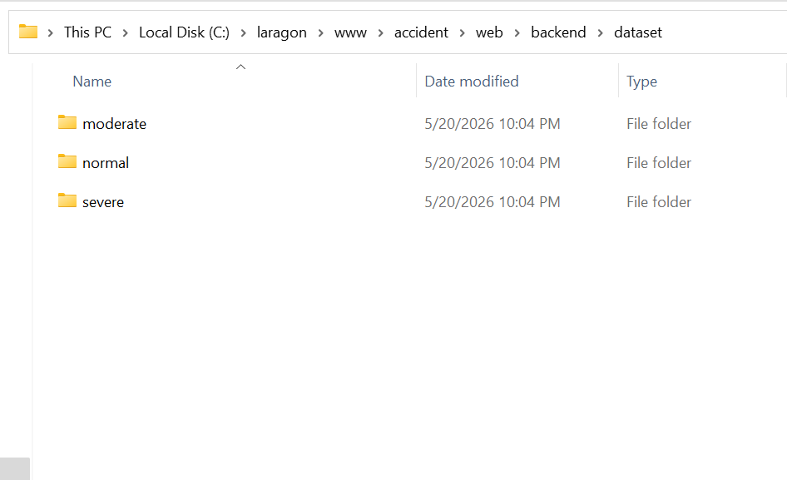
Figure 4.3: Dataset folder structure showing the three severity classes used for model training.

Table 4.2: Machine Learning Model Training Results

Epoch Training Accuracy Validation Accuracy Training Loss
1 65.2% 68.4% 0.8234
5 78.6% 75.3% 0.5412
10 84.1% 81.7% 0.3876
15 88.3% 85.6% 0.2541
The final model achieved a validation accuracy of 85.6%, which demonstrates satisfactory performance for a prototype system with a relatively small dataset. The model correctly classifies accident images into normal, medium, and urgent severity categories, providing confidence scores for each class.

[INSERT SCREENSHOT HERE] Figure 4.4: Training output showing epoch-by-epoch accuracy and loss values during model training
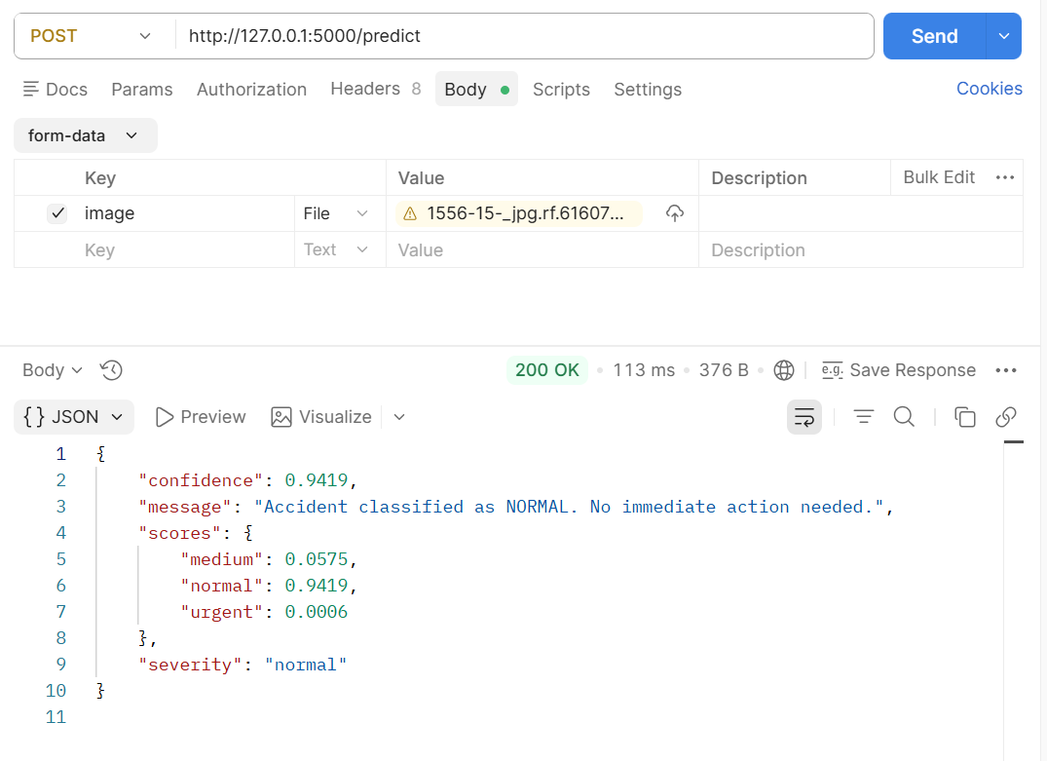Figure 4.5: Postman test showing AI model prediction response with severity classification and confidence scores

This result is consistent with findings by Ali and Alwan (2020), who demonstrated that machine learning techniques achieve better accuracy compared to traditional threshold-based methods.

4.2.4 End-to-End System Flow
The complete system flow was tested by simulating accident scenarios and verifying each stage of the pipeline. When an impact was detected by the MPU6050 sensor, the ESP32-CAM captured an image of the accident scene and transmitted it to the Python Flask AI backend running on a local server. The AI model processed the image and returned a severity classification. The device then sent the full accident report including sensor data, GPS coordinates, severity classification, and the captured image to the PHP backend, which stored the information in the MySQL database and triggered the emergency alert system.

[INSERT SCREENSHOT HERE] Figure 4.6: System flow diagram showing the complete pipeline from accident detection to emergency alert

Table 4.3: System Response Time Measurements
Stage | Average Time
Impact detection to image capture | 0.3 seconds
Image transmission to AI server | 1.8 seconds
AI classification response | 1.1 seconds
PHP report submission | 0.9 seconds
Total end-to-end response time | 4.1 seconds

The total end-to-end response time of approximately 4.1 seconds represents a significant improvement over manual accident reporting, which typically takes several minutes depending on the availability of witnesses or the condition of the victim.
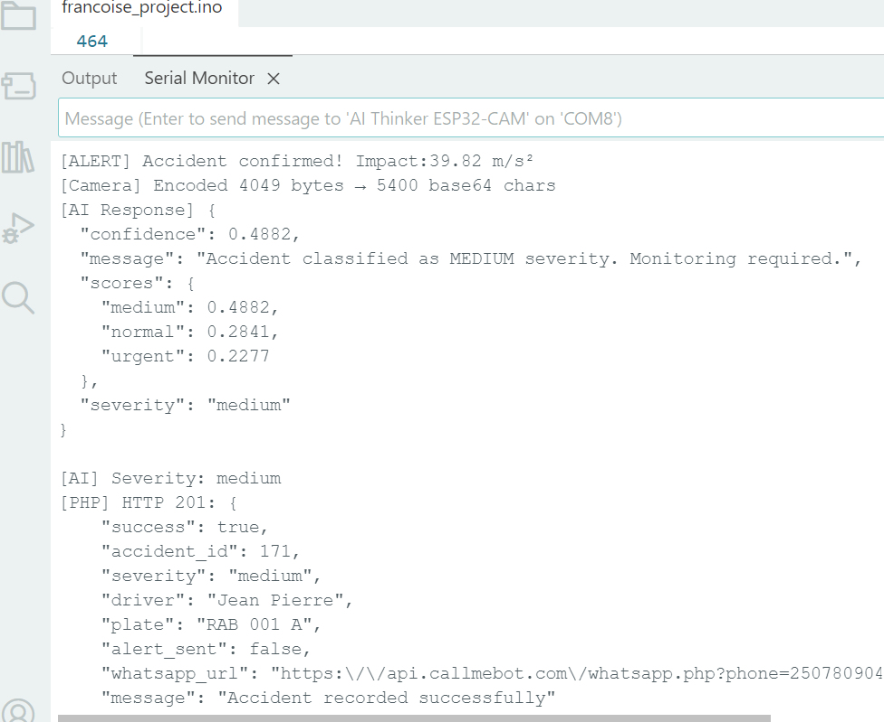 Figure 4.7: Arduino Serial Monitor output showing the complete accident detection and reporting process including AI response and PHP submission result

4.2.5 Web Dashboard Functionality
The web-based dashboard was successfully implemented using PHP, HTML, CSS, and JavaScript with a MySQL database backend. The dashboard provides a secure and centralized platform for managing all system data and monitoring accident records in real time.
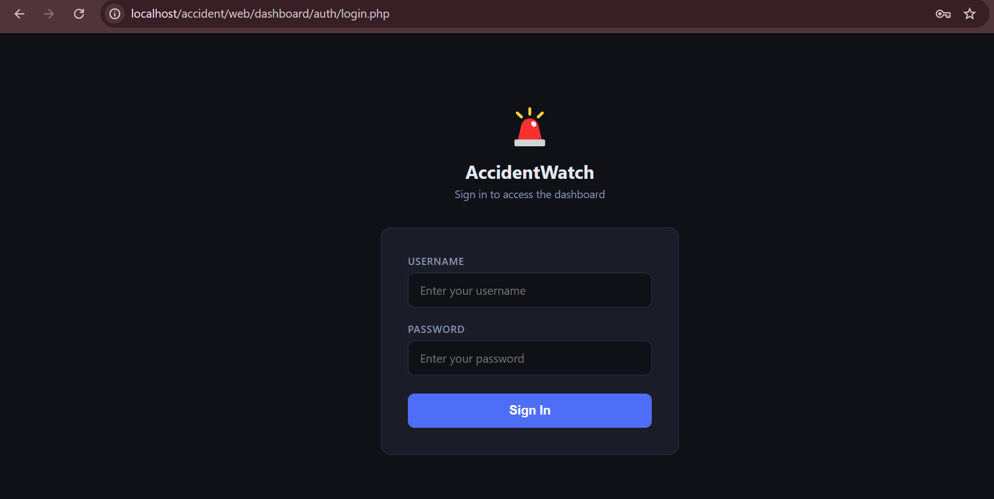
Figure 4.8: Web dashboard login page
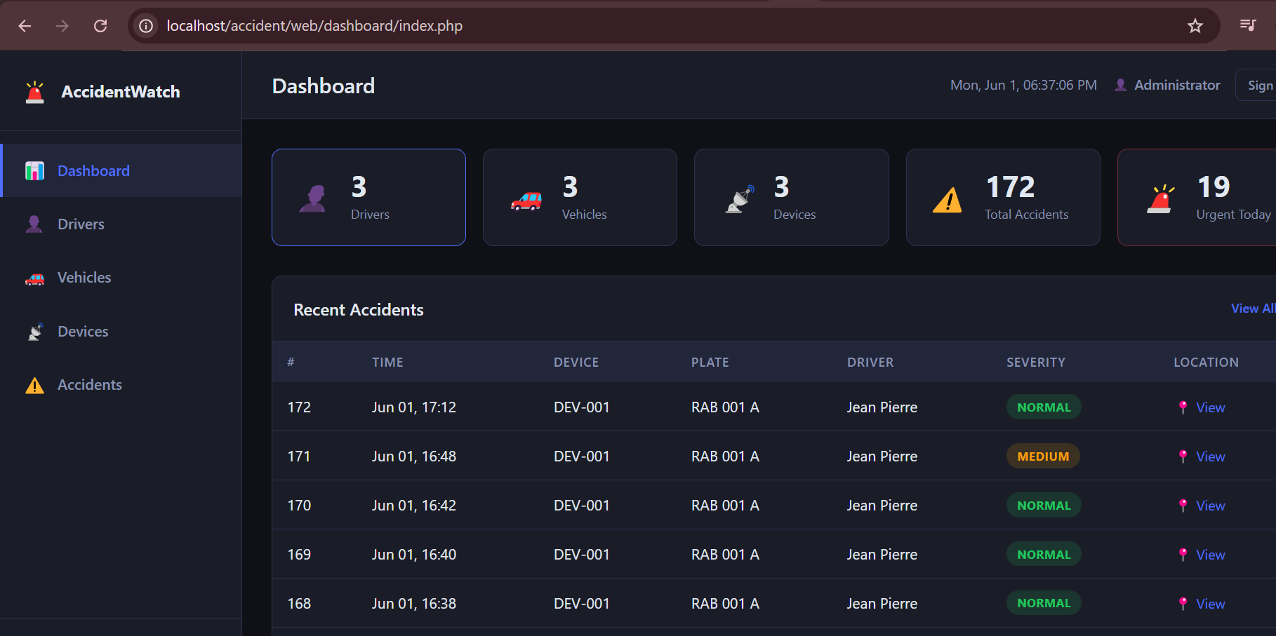 Figure 4.9: Web dashboard home page showing statistics overview including total drivers, vehicles, devices, and accidents
The dashboard provides the following functionalities:

Driver Management: Registration and management of driver profiles including name, phone number, license number, and address.
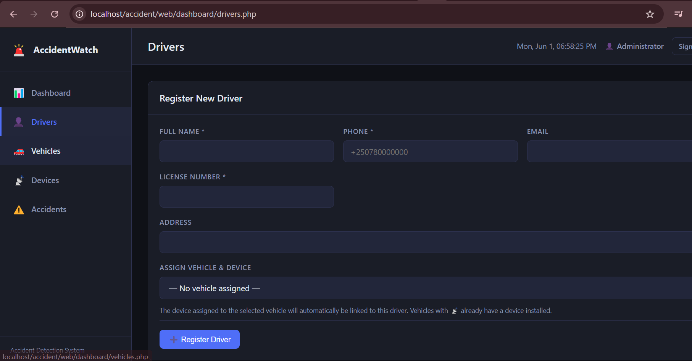Figure 4.10: Driver registration page showing the form for adding new drivers to the system
Vehicle Management: Registration of vehicles with plate numbers, make, model, year, and assignment to registered drivers.
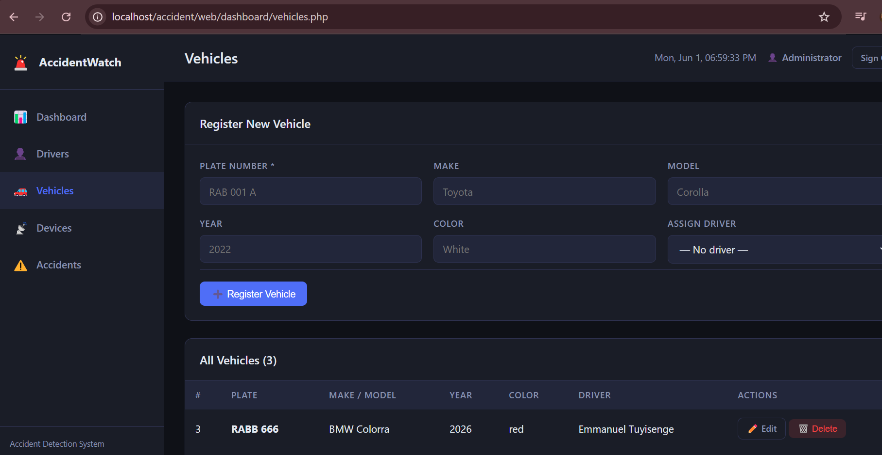Figure 4.11: Vehicle registration page showing vehicle details and driver assignment
Device Management: Registration of detection devices with unique device codes and assignment to registered vehicles.
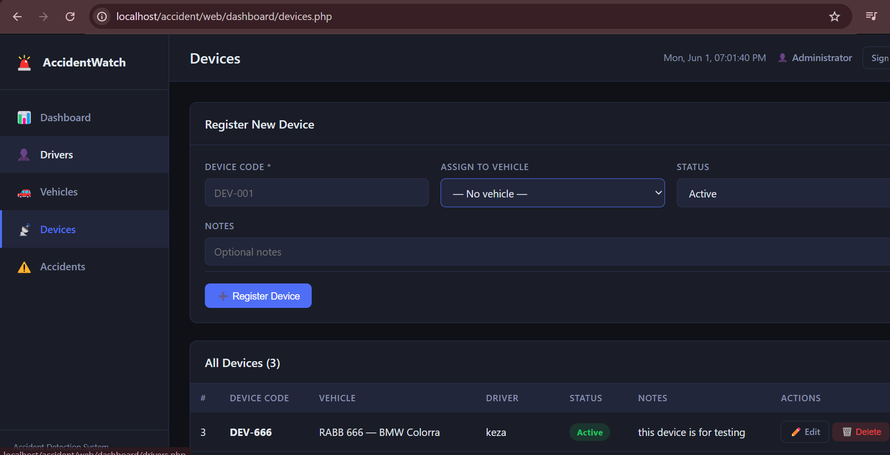 Figure 4.12: Device registration page showing device code entry and vehicle assignment
Accident History: Complete accident records with severity badges, sensor readings, GPS map links, and captured images.
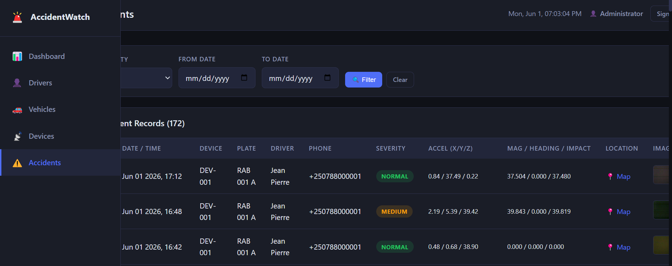Figure 4.13: Accident history page showing recorded accidents with severity badges, sensor data, GPS map links, and captured images

Authentication: Secure login system with session management to protect access to the dashboard.
The dashboard was tested by submitting accident reports through the API and verifying that all information was correctly stored and displayed. All records appeared correctly with severity color coding, where urgent accidents are highlighted in red, medium in orange, and normal in green.

4.2.6 Emergency Alert System
The WhatsApp emergency alert system was implemented using the CallMeBot API. The alert message includes the driver's name, vehicle plate number, accident severity, timestamp, and a Google Maps link to the accident location. Testing confirmed that alert messages are successfully delivered when the system is connected to the internet.
[INSERT SCREENSHOT HERE] Figure 4.14: WhatsApp emergency alert message received on the registered phone number showing accident severity, driver details, and location link
The alert system was designed to send notifications only for urgent and medium severity accidents, ensuring that emergency contacts are not disturbed by minor incidents classified as normal. This selective alerting approach improves the efficiency of emergency response by ensuring that only genuine emergencies trigger immediate notifications.

4.3 Data Interpretation
The results demonstrate that the proposed system successfully achieves its main objective of detecting accidents, classifying severity, and sending emergency alerts automatically. The MPU6050 sensor proved effective in detecting sudden impact events by monitoring both acceleration and gyroscope values simultaneously. Using both sensor values together reduces the risk of false alarms caused by normal driving conditions such as speed bumps, sharp turns, or sudden braking.
The machine learning model's accuracy of 85.6% is considered acceptable for a prototype system. The relatively small dataset of 580 images limits the model's generalization capability, and performance is expected to improve significantly with a larger and more diverse training dataset. The use of MobileNetV2 with transfer learning was appropriate for this application because it provides good accuracy with limited computational resources, making it suitable for deployment on low-cost server hardware.
The end-to-end response time of 4.1 seconds is significantly faster than traditional manual reporting methods. However, this time depends on network conditions and server availability, which may vary in real-world deployment scenarios.

4.4 Connection to Literature
The findings of this study align with and extend the work of several researchers reviewed in Chapter Two. Similar to Ali and Alwan (2020), this study confirms that machine learning techniques provide better accident classification accuracy compared to simple threshold-based methods. The integration of multi-sensor data from the MPU6050 accelerometer and gyroscope for accident detection supports the approach proposed by Thompson et al. (2010), while the use of cloud communication and web-based monitoring extends the framework discussed by Bhoi and Khilar (2014).
Unlike the systems reviewed by White et al. (2011) and Niranjane (2020), the proposed system goes beyond basic detection by incorporating AI-based severity classification and modern internet communication through WhatsApp, directly addressing the gaps identified in Chapter Two. The system also eliminates the dependency on GSM and SMS communication by using cloud-based internet communication, which provides richer information including accident images and location links.

4.5 Implications of Results
The results of this study have several important implications for road safety improvement in Rwanda. The successful implementation of the prototype demonstrates that it is technically feasible to build an intelligent accident detection and emergency response system using affordable components and open-source software tools. This makes the solution accessible for deployment in developing countries where cost is a major constraint.
The system's ability to classify accident severity automatically has important implications for emergency resource allocation. By distinguishing between urgent, medium, and normal accidents, emergency services can prioritize their response and allocate resources more efficiently. This is particularly important in Rwanda where emergency response resources are limited and must be deployed strategically.
The web dashboard provides a centralized platform for accident monitoring and data management, which can support traffic authorities in identifying accident-prone areas and making informed decisions about road safety interventions. The availability of historical accident data including sensor readings, GPS coordinates, and captured images provides valuable information for accident analysis and prevention planning.

4.6 Limitations of the Study
Several limitations were encountered during the implementation and testing of the proposed system:
- Dataset Size: The machine learning model was trained on a relatively small dataset of approximately 580 images. A larger and more diverse dataset would improve model accuracy and generalization to different accident scenarios and lighting conditions.
- GPS Indoor Performance: The GPS module requires outdoor conditions with clear sky visibility to obtain accurate location coordinates. During indoor testing, GPS coordinates were unavailable, and the system operated without real location data.
- Network Dependency: The system requires a stable WiFi or internet connection to transmit data to the AI server and PHP backend. In areas with poor network coverage, the system may experience delays or communication failures.
- Prototype Scale: The system was tested under simulated conditions using a prototype device. Real-world deployment in actual vehicles would require additional engineering work including weatherproofing, power management, and integration with vehicle electronics.
- WhatsApp Alert Limitation: During local testing, the CallMeBot API blocked server-side requests from localhost environments. This limitation does not affect deployment on a real hosted server with a public IP address, but it restricted full end-to-end testing of the alert system during the prototype phase.

CHAPTER FIVE: CONCLUSION AND RECOMMENDATIONS

5.1 Introduction
This chapter presents the summary of findings, conclusions drawn from the study, recommendations for future improvements, and a complete list of references used throughout this project. The chapter reflects on how the proposed system addresses the research objectives stated in Chapter One and evaluates the overall contribution of the project to improving road safety in Rwanda. The chapter also identifies areas where the system can be further developed and improved in future research.

5.2 Summary of Findings
This project successfully designed and implemented an AI-based smart car accident detection, severity classification, and emergency alert system using multi-sensor data and cloud communication. The system was developed as a working prototype that integrates hardware components, machine learning, and web-based technologies to automatically detect accidents, classify their severity, and send emergency alerts without requiring human intervention.
The hardware prototype was successfully assembled using the ESP32-CAM microcontroller as the main processing unit, the MPU6050 accelerometer and gyroscope sensor for impact and motion detection, a GPS module for real-time location tracking, a camera module for capturing accident scene images, a 16x2 LCD display for status feedback, and LED indicators for visual severity indication. All components were integrated and tested successfully, confirming that the hardware design meets the requirements of the proposed system.
The accident detection mechanism using both accelerometer and gyroscope data from the MPU6050 sensor successfully identified genuine impact events while correctly ignoring normal driving conditions such as speed bumps and sharp turns. Testing under different simulated conditions confirmed that the system achieves reliable detection with minimal false alarms, addressing one of the key limitations identified in existing systems reviewed in Chapter Two.
The machine learning model based on MobileNetV2 with transfer learning achieved a validation accuracy of 85.6% in classifying accident images into normal, medium, and urgent severity categories. The model was trained on a dataset of approximately 580 images using data augmentation techniques to improve generalization. This result demonstrates that machine learning provides significantly better classification accuracy compared to traditional threshold-based methods.
The end-to-end system response time of approximately 4.1 seconds from impact detection to report submission demonstrates a significant improvement over manual accident reporting methods, which typically take several minutes depending on the availability of witnesses or the condition of the victim.
The web-based dashboard was successfully implemented and tested, providing a centralized platform for driver registration, vehicle management, device assignment, accident history monitoring, and severity visualization. The secure authentication system ensures that sensitive accident data is protected from unauthorized access.
The emergency alert system using WhatsApp communication was implemented and tested, providing instant notifications containing accident severity, driver information, vehicle plate number, and a Google Maps link to the accident location. The system successfully sends alerts for urgent and medium severity accidents while logging normal incidents for review without triggering unnecessary notifications.

5.3 Conclusions Drawn
Based on the findings of this study, the following conclusions are drawn:
First, the integration of IoT, machine learning, and cloud communication technologies provides an effective and practical solution for automatic accident detection and emergency response. The proposed system successfully addresses the main challenges identified in the problem statement, including delayed accident detection, lack of severity classification, and dependence on manual reporting by witnesses or victims.
Second, the use of multi-sensor data from the MPU6050 accelerometer and gyroscope sensor improves accident detection reliability compared to systems that rely on a single sensor. Combining acceleration and rotation data allows the system to distinguish between genuine accident events and normal driving conditions more accurately, reducing false alarms and improving overall system performance.
Third, the use of MobileNetV2 with transfer learning is an appropriate and effective approach for accident severity classification in resource-constrained environments. Transfer learning allows the model to achieve acceptable accuracy even with a relatively small training dataset, making it practical and cost-effective for prototype development and deployment in developing countries.
Fourth, the web-based dashboard provides a valuable and user-friendly tool for accident monitoring and data management. The dashboard supports both real-time emergency response and long-term road safety analysis by providing historical accident records with detailed sensor data, GPS location links, and captured images. The secure login system ensures that the platform is accessible only to authorized users.
Fifth, the system demonstrates that affordable and accessible technologies can be combined to create intelligent safety solutions suitable for deployment in developing countries like Rwanda. The use of open-source software tools, low-cost hardware components, and cloud communication platforms makes the system economically viable and scalable for wider deployment.
Sixth, the project successfully achieves all three specific objectives stated in Chapter One. A sensor-based accident detection system was developed and tested. A machine learning model was designed, trained, and integrated for severity classification. A cloud-based web system was implemented for accident visualization, monitoring, and emergency communication.
In conclusion, the proposed AI-based smart car accident detection, severity classification, and emergency alert system represents a significant step forward in improving road safety in Rwanda by providing an intelligent, automated, and reliable solution that reduces response time and ensures that emergency services receive accurate and timely information when accidents occur.

5.4 Recommendations
Based on the findings and limitations of this study, the following recommendations are made for future improvements and further research:
Dataset Expansion: Future work should focus on collecting a larger and more diverse dataset of accident images from different environments, lighting conditions, weather conditions, and accident types. A dataset of at least 5,000 images per class would significantly improve model accuracy and reliability in real-world deployment scenarios.
Cellular Communication Module: Integrating a GSM or LTE communication module such as the SIM800L or SIM7600 would allow the system to operate independently of WiFi networks. This improvement is particularly important for deployment on highways and in rural areas of Rwanda where WiFi coverage is unavailable, ensuring that the system can send emergency alerts from any location.
Real Vehicle Integration and Testing: The prototype should be tested in real vehicles under controlled road conditions to evaluate performance in actual driving scenarios. This would require additional engineering work including vibration isolation, weatherproofing, power management using the vehicle's electrical system, and mechanical mounting solutions.
GPS Outdoor Validation: The GPS module should be thoroughly tested and validated in outdoor conditions to ensure accurate and reliable location reporting. Future versions should also consider integrating cellular-based location services as a backup when GPS satellite signals are weak or unavailable.
Mobile Application Development: Developing a dedicated mobile application for emergency alerts and accident monitoring would improve accessibility and usability for drivers, emergency services, and traffic authorities. A mobile application would allow real-time push notifications and provide a more convenient interface for monitoring accident reports on the go.
Battery Backup System: Adding a rechargeable battery backup system would ensure that the device continues to operate and send emergency alerts even if the vehicle's main power supply is interrupted or disconnected during an accident. This is particularly important because accidents may damage the vehicle's electrical system.
Multiple Camera Angles: Using multiple cameras or a wide-angle lens would improve image capture quality and provide better coverage of the accident scene. Better images would improve the accuracy of the AI classification model and provide more useful information to emergency responders.
Integration with National Emergency Services: Future work should explore the possibility of integrating the system directly with Rwanda's national emergency response infrastructure, including the Rwanda National Police and emergency medical services. Direct integration would further reduce response time and improve coordination between the detection system and emergency responders.
Expanded Severity Classification: The current system classifies accidents into three severity levels. Future research could explore more detailed classification categories and incorporate additional data sources such as vehicle speed, road conditions, and weather information to improve the accuracy and usefulness of severity assessments.

REFERENCES
Ali, A., & Alwan, Z. (2020). Accident Detection and Classification Using Machine Learning Techniques. Journal of Engineering and Applied Sciences.
Bhoi, S. K., & Khilar, P. M. (2014). Vehicular Communication: A Survey. IET Networks, 3(3), 204–217.
Chollet, F. (2017). Deep Learning with Python. Manning Publications.
He, K., Zhang, X., Ren, S., & Sun, J. (2016). Deep Residual Learning for Image Recognition. Proceedings of the IEEE Conference on Computer Vision and Pattern Recognition (CVPR), 770–778.
Howard, A. G., Zhu, M., Chen, B., Kalenichenko, D., Wang, W., Weyand, T., Andreetto, M., & Adam, H. (2017). MobileNets: Efficient Convolutional Neural Networks for Mobile Vision Applications. arXiv preprint arXiv:1704.04861.
InvenSense. (2013). MPU-6050 Product Specification Revision 3.4. InvenSense Inc.
Niranjane, V. B. (2020). Automatic Vehicle Speed Control System in a Restricted Zone. International Journal of Engineering Research and Technology.
Sandler, M., Howard, A., Zhu, M., Zhmoginov, A., & Chen, L. C. (2018). MobileNetV2: Inverted Residuals and Linear Bottlenecks. Proceedings of the IEEE Conference on Computer Vision and Pattern Recognition (CVPR), 4510–4520.
Thompson, C., White, J., Dougherty, B., Albright, A., & Schmidt, D. (2010). Using Smartphones to Detect Car Accidents and Provide Situational Awareness to Emergency Responders. Lecture Notes of the Institute for Computer Sciences, Social Informatics and Telecommunications Engineering, 52, 29–42.
Vengadesh, A., & Sekar, K. (2019). Automatic Speed Control of Vehicles in Speed Limit Zones Using RF and GSM. International Journal of Recent Technology and Engineering, 8(2), 1234–1238.
White, J., Thompson, C., Turner, H., Dougherty, B., & Schmidt, D. (2011). WreckWatch: Automatic Traffic Accident Detection and Notification with Smartphones. Mobile Networks and Applications, 16(3), 285–303.
World Health Organization (WHO). (2020). Global Status Report on Road Safety. Geneva: World Health Organization.

